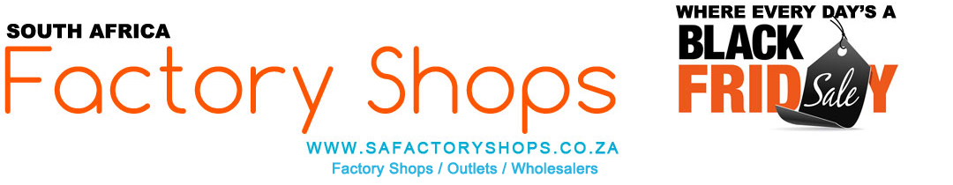
www.safactoryshops.co.za
Where Every Day's a Black Friday
Southern Africa's Leading Online Factory Shopping Portal
Southern Africa's Biggest Facebook Shopping Group

This document is updated regularly. Please ensure that you have the latest version at all times.
Last updated: 22 April 2024
Visit our Facebook group by clicking here.
Specials and Sales info can be found by clicking here.

Search for anything at www.safactoryshops.co.za by keyword, suburb or brand name by typing in what you are looking for in the online search functionality fields.
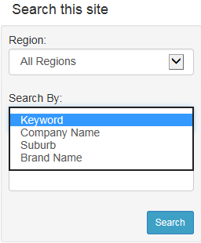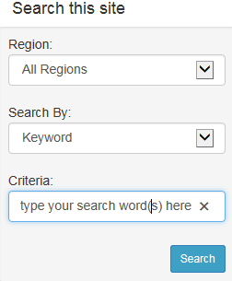

Browse a national Google map to find the leading factory shops closest to you

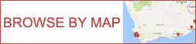
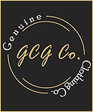

A COMPLETE LIST OF ALL FACTORY SHOPS AND OUTLETS ADVERTISING AT WWW.SAFACTORYSHOPS.CO.ZA
Please click on the links below to take you directly to their factory shop adverts

Bedding
Dream Home Textiles Factory Shop
Duvets and Pillows from Home Factory Shop
Romatex Bedding and Linen Factory Shop
Genuine Clothing Bedding Factory Shop Cape Town
Genuine Clothing Bedding Factory Shop Johannesburg
Carpets and Rugs
Cape Rug Company Carpets Factory Shop

China Town
Sonia's Salon China Town Sable Square Shop A32

Clothing
Beeline Children's Clothing Factory Shop Brackenfell
Beeline Children's Clothing Factory Shop Lansdowne
Beeline Children's Clothing Factory Shop Paarl
Beeline Children's Clothing Factory Shop Wynberg
Genuine Clothing Bedding Factory Shop Cape Town
Genuine Clothing Bedding Factory Shop Johannesburg
Oggi Activewear Factory Shop
Sonia's Salon China Town Sable Square Shop A32
Curtains
Dream Home Textiles Factory Shop
Svenmill Curtaining Factory Shop
Fabrics/ Textiles
FVW Fashion Ventana Warehouse Fabrics Textiles Factory Shop
Food
Mr. No Jokes Discounted Groceries Factory Shop Stikland
Mr. No Jokes Discounted Groceries Factory Shop Montague Gardens
Mr. No Jokes Discounted Groceries Factory Shop Ottery
MultiSnack Nuts and Dried Fruit Factory Shops Cape Town
MultiSnack Nuts and Dried Fruit Factory Shops Johannesburg
Red Rose Cash and Carry Food and Nappy Factory Shops
The Chocolates, Sweets and Biscuits Factory Shop
Nappies
Red Rose Cash and Carry Food and Nappy Factory Shop
Salvaged Goods
Salvage Co. Salvaged Goods Factory Shop

Sports
Oggi Activewear Factory Shop
Swimwear
Oggi Activewear Factory Shop
Towels
Dream Home Textiles Factory Shop

Contact the publishers

FIND THE FACTORY SHOPS CLOSEST TO YOU BY BROWSING A NATIONAL GOOGLE MAP
CLICK ON THE IMAGE BELOW TO ACCESS THIS USER FRIENDLY FEATURE
