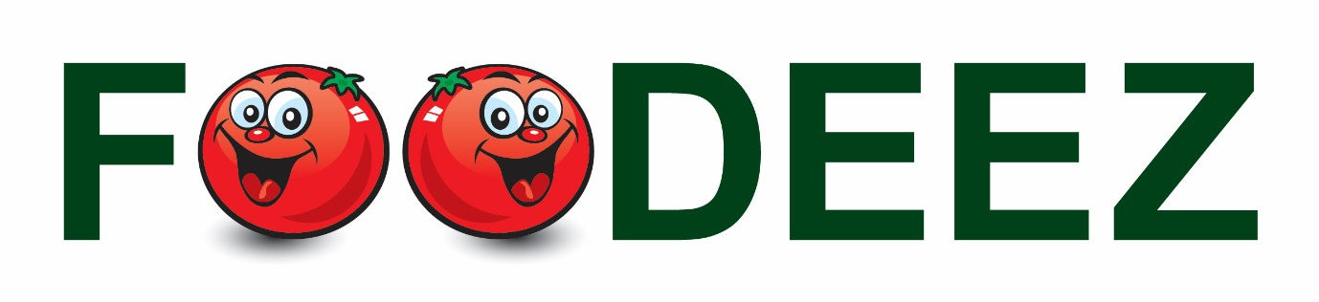

Dear Foodeez customers,

There are signs at the entrance to all our shops that indicate what kind of store we are. Our concept is to recover non-perishable food that is either short-dated or dated, food destined for dumping in landfill sites. We pre-empt this process, buy the food direct from the manufacturers and sell it at hugely discounted prices direct to the public.
This is all food that is perfectly safe for human consumption, but because people don't understand what Best Before dates mean they won't buy it and manufacturers and retailers have to dump it instead. It is a wicked waste of food; it is bad for the environment and a crazy thing to do when people are battling to make ends meet. I would also like to clarify the issue around 'expired' food.
We don't sell expired food - we sell shelf stable non-perishable food that has reached or passed its best before date. A BB date is merely an indication of when the manufacturer believes that product will still be at optimum quality. All products will gradually deteriorate, often over many years, in terms of texture, colour and sometimes taste. It is highly unlikely that you would be able to tell the difference in taste between a pre BB date product and post BB date product. And remember, a BB date is NOT a food safety date.
I hope this puts the Foodeez operation in perspective. We are hoping to effect change, one small step at a time, and if we can convince people such as you to assist us in spreading the word, we will make an impact in reducing food wastage in our country.

Kind regards

Dave Bester
Managing Director - Foodeez

