
BLINDS PRICE LIST
15 February 2015
Tel: +27 (0)21 706 2733
Cell: +27 (0)71 472 5439
Address: 93 5th Avenue, Grassy Park, Cape Town (Corner 5th Avenue and Library Road)
Email: curtainworldhm@gmail.com
Aluminium venetian blinds 25 mm (Plain colours)

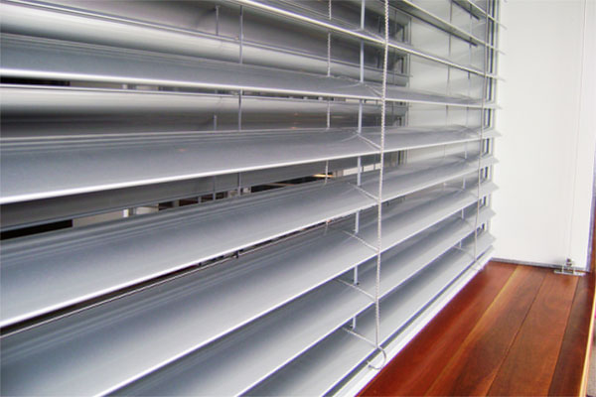

Size chart and price
600 x 600 = R160
600 x 900 = R18
600 x 1 200 = R209
600 x 1 500 = R234
600 x 2 000 = R276
600 x 2 200 = R292
600 x2 500 = R317
900 x 600 = R218
900 x 900 = R233
900 x 1 200 = R292
900 x 1 500 = R330
900 x 2 000 = R392
900 x 2 200 = R417
900 x 2 500 = R454
1 200 x 600 = R271
1 200 x 900 = R320
1 200 x 1 200 = R370
1 200 x 1 500 = R419
1 200 x 2 000 = R501
1 200 x 2 200 = R534
1 200 x 2 500 = R583
1 500 x 600 = R333
1 500 x 900 = R395
1 500 x 1 200 = R456
1 500 x 1 500 = R518
1 500 x 2 000 = R621
1 500 x 2 200 = R662
1 500 x 2 500 = R724
2 000 x 600 = R980
2 000 x 900 = R1 130
2 000 x 1 200 = R1 290
2 000 x 1 500 = R1 450
2 000 x 2 000 = R1 700
2 000 x 2 200 = R1 800
2 000 x 2 500 = R2 000
2 500 x 600 = R1 190
2 500 x 900 = R1 380
2 500 x 1 200 = R1 570
2 500 x 1 500 = R1 760
2 500 x 2 000 = R2 090
2 500 x 2 200 = R2 212
2 500 x 2 500 = R2 410

Aluminium venetian blinds 50 mm (Plain colours)
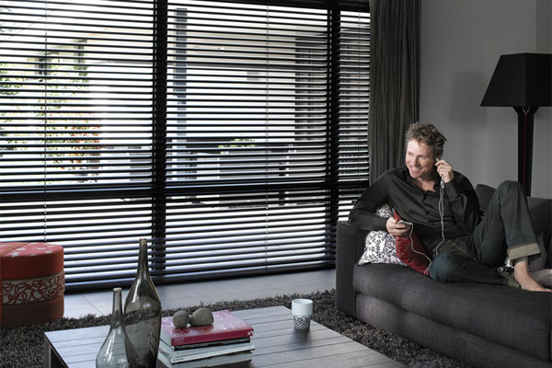

Size chart and price
600 x 600 = R325
600 x 900 = R370
600 x 1 200 = R410
600 x 1 500 = R443
600 x 2 000 = R510
600 x 2 200= R537
600 x 2 500= R580
900 x 600 = R433
900 x 900 = R495
900 x 1 200 = R560
900 x 1 500 = R615
900 x 2 000 = R720
900 x 2 200 = R760
900 x 2 500 = R820
1 200 x 600 = R528
1 200 x 900 = R607
1200 x 1 200 = R690
1200 x 1 500 = R770
1 200 x 2 000 = R898
1 200 x 2 200 = R951
1 200 x 2 500 = R1 030
1 500 x 600 = R700
1 500 x 900 = R752
1 500 x1 200 = R852
1 500 x1 500 = R951
1 500 x 2 000 = R1 200
1 500 x 2 200 = R1 183
1 500 x 2 500 = R1 290
2 000 x 600 = R980
2 000 x 900 = R1 130
2 000 x 1 200 = R1 290
2 000 x 1 500 = R1 450
2 000 x 2 000 = R1 700
2 000 x 2 200 = R1 800
2 000 x 2 500 = R2 000
2 500 x 600 = R1 190
2 500 x 900 = R1 380
2 500 x 1 200 = R1 570
2 500 x 1 500 = R1 760
2 500 x 2 000 = R2 090
2 500 x 2 200 = R2 212
2 500 x 2 500 = R2 410

Aluminium venetian blinds 50 mm (Wood look)
Size chart and price

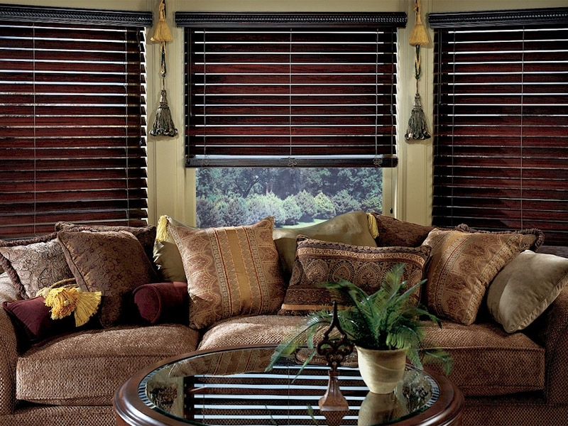
600 x 600 = R377
600 x 900 = R424
600 x 1 200 = R500
600 x 1 500 = R540
600 x 2 000 = R600
600 x 2 200 = R640
600 x 2 500 = R680
900 x 600 = R520
900 x 900 = R600
900 x 1 200 = R650
900 x 1 500 = R730
900 x 2 000 = R840
900 x 2 200 = R890
900 x 2 500 = R680
1 200 x 600 = R620
1 200 x 900 = R720
1 200 x 1 200 = R820
1 200 x 1 500 = R900
1 200 x 2 000 = R1 055
1 200 x 2 200 = R1 120
1 200 x 2 500 = R1 210
1 500 x 600 = R770
1 500 x 900 = R850
1 500 x 1 200 = R1 000
1 500 x 1 500 = R1 115
1 500 x 2 000 = R1 320
1 500 x 2 200 = R1 388
1 500 x 2 500 = R1 510
2 000 x 600 = R980
2 000 x 900 = R1 130
2 000 x 1 200 = R1 290
2 000 x 1 500 = R1 450
2 000 x 2 000 = R1 700
2 000 x 2 200 = R1 800
2 000 x 2 500 = R2 000
2 500 x 600 = R1 190
2 500 x 900 = R1 380
2 500 x 1 200 = R1 570
2 500 x 1 500 = R1 760
2 500 x 2 000 = R2 090
2 500 x 2 200 = R2 212
2 500 x 2 500 = R2 410

Wooden or bamboo venetian blinds 50 mm

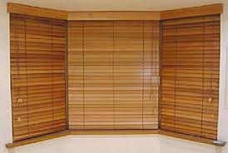

Size chart and price

600 x 600 = R457
600 x 900 = R548
600 x 1 200 = R638
600 x 1 500 = R728
600 x 2 000 = R878
600 x 2 200 = R938
600 x 2 500 = R1 028
900 x 600 = R638
900 x 900 = R773
900 x 1 200 = R908
900 x 1 500 = R1 191
900 x 2 000 = R1 269
900 x 2 200 = R1 359
900 x 2 500 = R1 494
1 200 x 600 = R803
1 200 x 900 = R981
1 200 x 1 200 = R1 160
1 200 x1 500 = R1 339
1 200 x 2 000 = R1 636
1 200 x 2 200 = R1 755
1 200 x 2 500 = R1 934
1 500 x 600 = R997
1 500 x 900 = R1 220
1 500 x 1 200 = R1 444
1 500 x 1 500 = R1 667
1 500 x 2 000 = R2 040
1 500 x 2 200 = R2 189
1 500 x 2 500 = R2 413
2 000 x 600 = R1 344
2 000 x 900 = R1 656
2 000 x 1 200 = R1 968
2 000 x 1 500 = R2 280
2 000 x 2 000 = R2 800
2 000 x 2 200 = R3 008
2 000 x 2 500 = R3 320
2 500 x 600 = R1 919
2 500 x 900 = R2 380
2 500 x 1 200 = R2 841
2 500 x 1 500 = R3 302
2 500 x 2 000 = R4 070
2 500 x 2 200 = R4 376
2 500 x 2 500 = R4 838

We also have the following blinds available for more information please do not hesitate to contact us.
021 706 2733
0714725439
curtainworldhm@gmail.com

Roman blinds

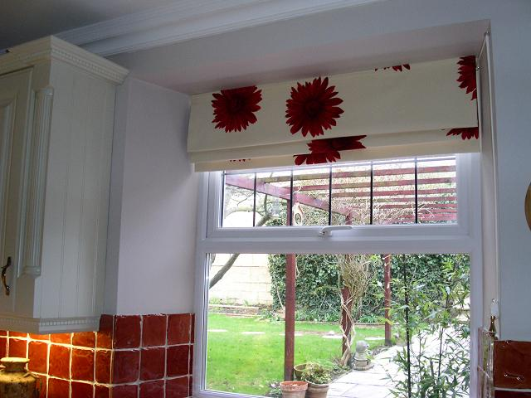

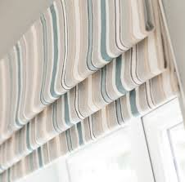

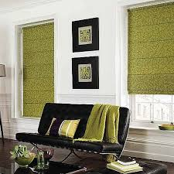

Pannel blinds

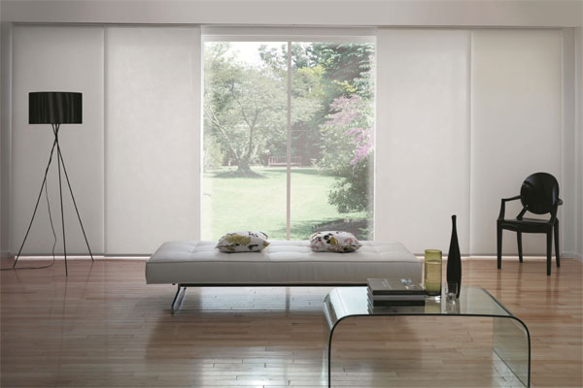

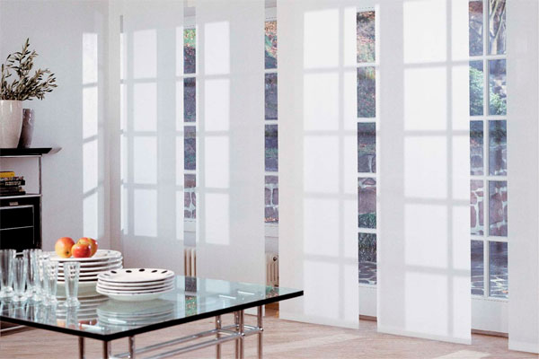

Vertical blinds

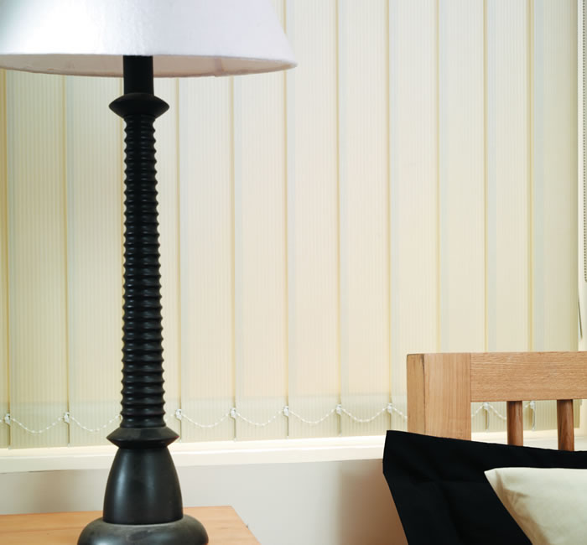

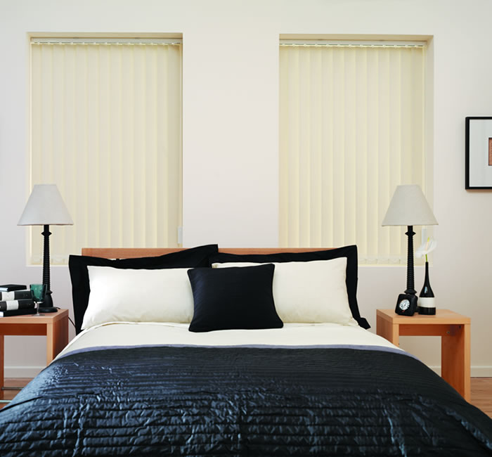

Bamboo rolla blinds

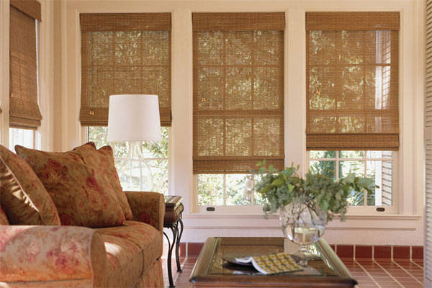

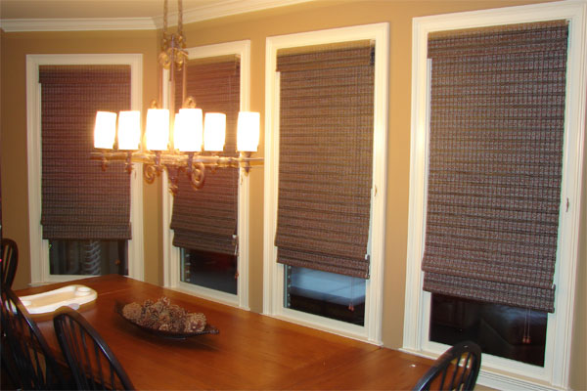

Motorized blinds available in rolla and panel blinds



